Check against delivery

ICELAND
Statement by Ms. Edda Ragnarsdottir
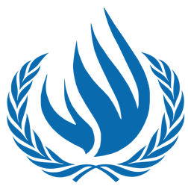

UPR 26th Session - South Sudan
November 2016

www.iceland.is/iceland-abroad/efta

Mr. President,
Iceland welcomes the delegation of South Sudan to their UPR review.
The resumption of violence in South Sudan is of serious concern to my Government including the inability of UN peacekeepers to ensure the safety and security of civilians, as witnessed in these last six months.

The fault lies with the two parties, who have continued their agenda despite pleas from the International Community to refrain from war.

We urge the Government to fully implement the signed peace agreement designed to end South Sudan’s nearly civil war

Iceland recommends to South Sudan the following:
- Provide full access for journalists, human rights organizations and other members of civil society to all areas of the country, including conflict-affected areas;
- Undertake prompt, effective and impartial investigations into allegations of crimes under international law and human rights violations;
- Bring all those suspected of criminal responsibility to justice in open, accessible ordinary civilian courts and in fair trials without recourse to the death penalty;

Thank you

